**Te121`**

ITMD 455/555 *Intelligent Device Applications* Lab 1

#### Temperature Converter App- 50 points

**Introduction**. This lab will have you create a simple temperature conversion app! Instructions include how to drag and drop into a layout view, to add User Interface (UI) components to the view, add/set properties for your components as well as manually add and edit various files. Also included is the functionality of the app that will be applied with an added Java class.

Controls for this app include EditText, Button, RadioGroup, RadioButtons and an ImageView.

Interface of the app at runtime shown below is what you will be similarly building for this lab.

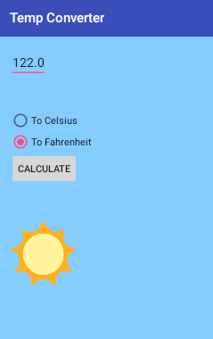

**STEP 1 Creating a New Android Project**

Start up Android Studio.

Use the Create New Project wizard to create your project by doing the following:

1. Click on the option ‘Start a new Android Studio project’ seen on the Welcome screen if you are confronted with a Splash screen, otherwise just go to your menu and choose **New> New Project**.

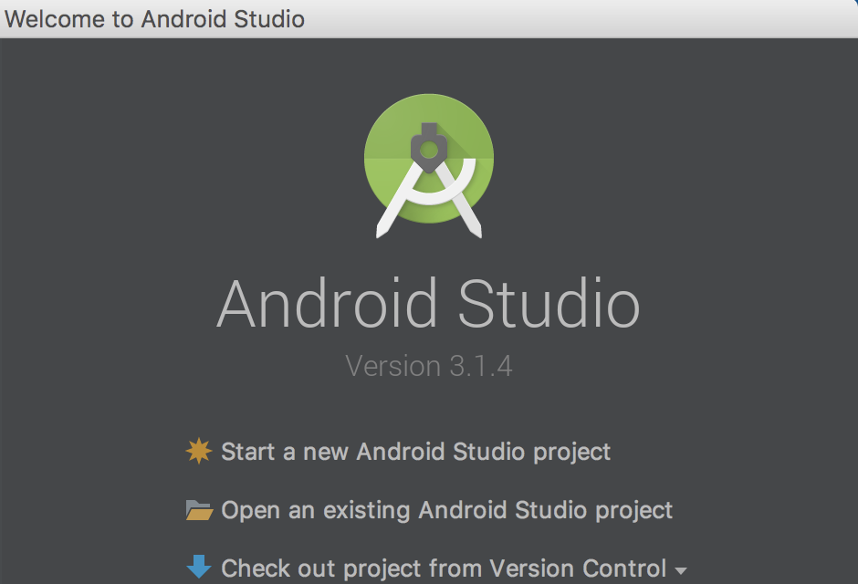

Here a New Project dialog box appears where you can configure your new app.

Enter in the Application name as shown below, and a project location of your choice, keep all other

settings as defaulted then chose Next.

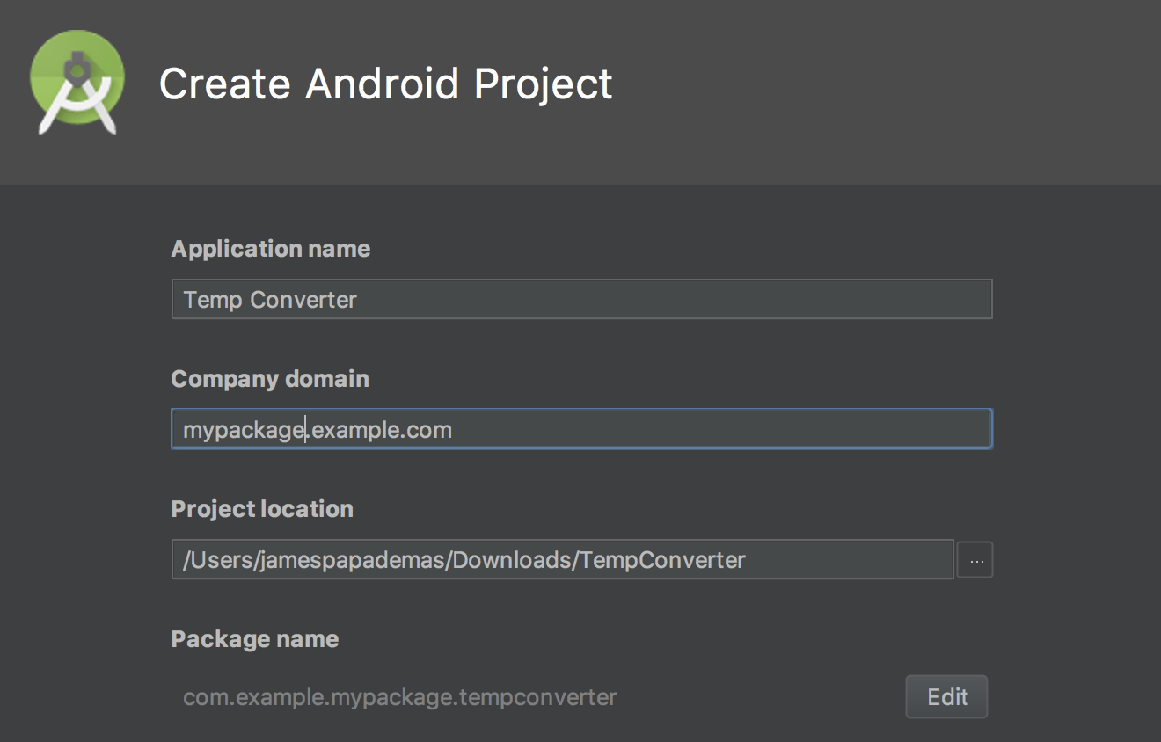

(*Note*- the Application Name will serve as the title of your app when it runs)

1. In the ‘Target Android Devices’ screen that appears next, for the first dropdown menu choice choose API level 28 and keep all other defaults and once again press Next.

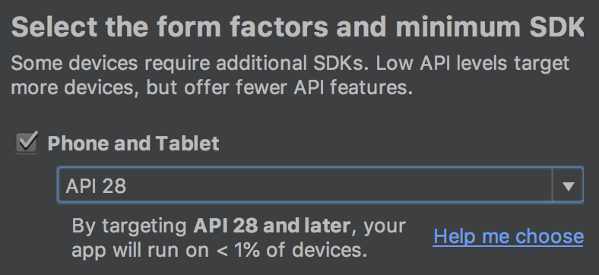

1. For the next screen namely ‘Add an activity to Mobile’, keep or select the default

**Empty Activity** choice and press Next.

1. For your last screen, ‘Customize the Activity’, keep the default settings (as shown below) and press Finish when complete.

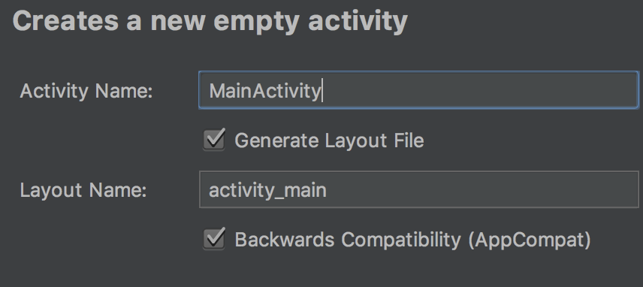

(*Note*- the name of the activity class is given as MainActivity with a correspnding layout

name of activty_main)

Your project now creates itself.

Take a moment to familiarize yourself with your IDE, its layouts, menus, values that are part of your Project tree you see below. Notice the nice tab structure (known as the Navigation Bar) tool for quick navigation to your files.

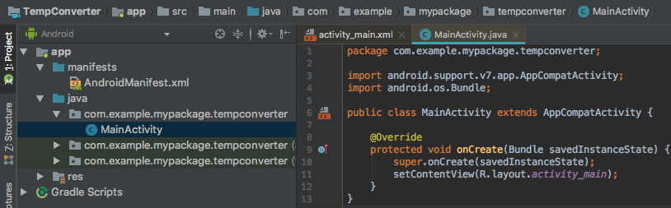

**STEP 2 Creating project attributes**

We will start our project showing how Android allows you to create static resources that define attributes, e.g., for Strings or colors, etc. These attributes can be defined in XML files or by Java source code.

Select (double click) from your project tree, the *res/values/strings.xml* file to open the editor for this file.

As a start, add in a color tag by adding the following line to your strings.xml file within your <resources> root tag

<**color name="myColor"**>#FFE4E1</**color**>

Notice what has been entered. **myColor** value has been included for the attribute name and the inner XML value shows the Hex color of **#FFE41.** This will eventually be used to serve as a nice *mistyrose* background color to your app.

Next add in some strings that will contain attribute values for common temperature displays. To add in various string attributes quickly without typing in any XML, you can simply click on the Open editor link towards the right top side of your IDE.

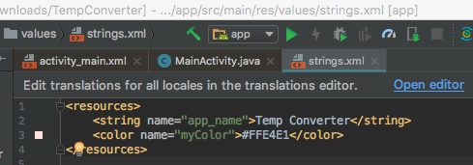

This will allow you to simply and rapidly add in a key/value pair denoting programmer defined values.

At this point, enter in your key/value data by pressing the Add Key  symbol within your Translations Editor tab and enter the following into your pop up.

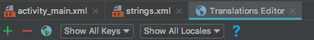

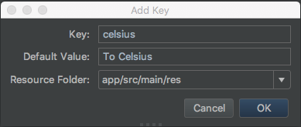

Click on OK to commit your information. Your resource file now has been updated to include your new string data as shown below in the rectangle symbol.

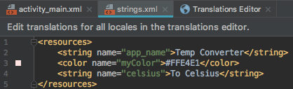

Do the same action and add in the following two additional attributes that follow

**String Attributes add-ons**

|  |  |
| --- | --- |
| **Name** | **Value** |
| fahrenheit | To Fahrenheit |
| calc | Calculate |

Notice the Translation Editor view now depicts all your new entries as well as the default key namely app_ name! Snapshot follows. Note your order by Keys shown next may vary.

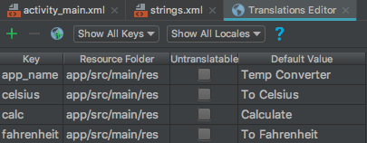

Once your update your XML settings, close the Translations Editor tab  to view and validate your edited XML file. It should now resemble something like this.

<**resources**>  
 <**string name="app_name"**>Temp Converter</**string**>  
 <**color name="myColor"**>#FFE4E1</**color**>  
 <**string name="celsius"**>To Celsius</**string**>  
 <**string name="fahrenheit"**>To Fahrenheit</**string**>  
 <**string name="calc"**>Calculate</**string**>  
</**resources**>

If something is off, feel free to edit your results right in the XML file. A good idea would be to save your files at this point and any time really when editing, updating or coding any files.

**STEP 3 Using the layout editor for setting a UI**

Select (double-click) the ***res/layout/activity_main.xml*** file. The associated Android editor allows you to create the physical layout via drag and drop in **Design** view and/or via the XML source code inside your **Text** view! You can switch between both representations via the tabs at the bottom of the editor.

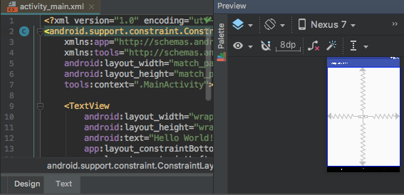

The following shows a snapshot of a Palette when in Design mode. This feature allows you to drag and drop new **View** elements to your layout. Simply click on any of the Palette items to view it contents.

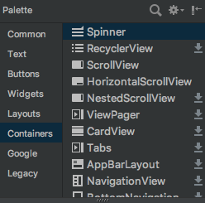

**STEP 4 Adding View elements to your layout file**

Layout views in Android allows for the addition of user interface components. Here you will create the base user interface (UI) for your application.

From your Design view, right-click on the existing Hello World! text object in the layout. Select Delete from the popup menu to remove the text object. Snapshot follows.

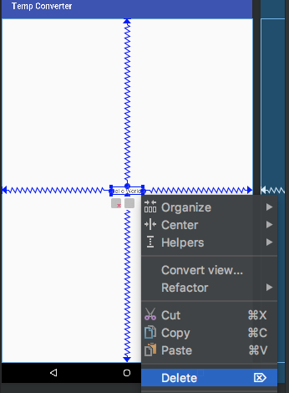

Get familiar with your surroundings concerning your Layout views! For example, check your Component Tree and Attributes (or properties) sections to the left/right of your Design interface.

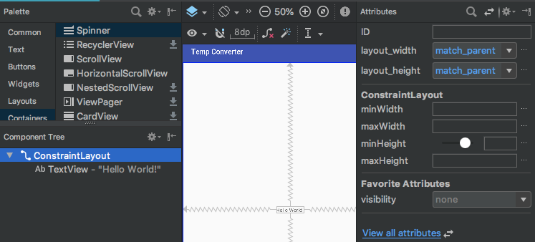

Use the Component Tree section to quickly pinpoint elements from your Tree layout or even add elements from your Palette directly by dragging objects from the Palette right within your tree! Very cool indeed. Also use the Attributes section to quickly ‘tweak’ elements for such things as height or width adjustments to your layout design elements, etc. in a snap! No fooling around with XML. You’ll see working these sections next.

Now from your Palette*,* select the **Text Fields** section and note all the text field choices. Locate the **Number (Decimal)** choice and drag it onto your layout (interface) thus creating an editable text input field as your first element added to your interface.

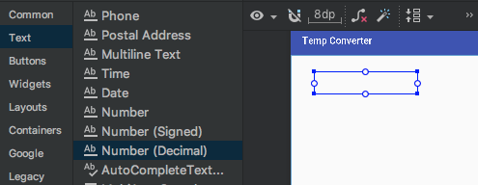

Drag it over

If you view your XML on this, you will notice that the Text Field element has been assigned a new **android:id** attribute as follows:

**android:id="@+id/editText"**

**Keynote**

All entries in the Text Fields section of your XML file you’ll see, define

text fields. Various entries define *“added*” attributes for them, ex. if

a text field should allow input only for numbers, or allow for negative values as

well, etc.. check it:

<EditText  
 android:id="@+id/editText"  
 ::

android:inputType="numberDecimal"  
 tools:layout_editor_absoluteX="48dp"  
 tools:layout_editor_absoluteY="34dp" />

Next select the Buttons section in the Palette and drag a **RadioGroup** entry into your layout and place it directly under your text view (it should snap right in). Notice how your Component Tree area, tree looks each time your adding elements in. You can always click on an element in your tree to quickly focus on it to delete it, or view its specific properties Attributes.

Next grab two **RadioButton** objectsfrom your Widgetssection from your Palette and drag each button directly into your RadioGroup within your Component Tree (as shown below) to make it easier for direct placement of these elements. You want RadioButtons to be part of your RadioGroup making coding easier to see what a user has selected.

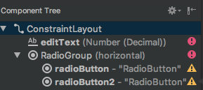

Notice that the id’s are given (as shown above) automatically when you’ve dragged them into your Tree, namely **radioButton** and **radioButton2**. Id’s are always important so you can reach out or refer to the elements in code later on. Notice also default text is given to the buttons. That will be adjusted soon in your Attributes view.

Finally drag a Button from the Widgets section onto the screen layout area under your RadioGroup. The button should now sit nicely right under RadioGroup element!



Make sure to include adequate spacing between your widgets to ensure your controls don’t bunch up in your layout. The resulting XML layout should look something like the following.

<?xml version="1.0" encoding="utf-8"?>  
<android.support.constraint.ConstraintLayout xmlns:android="http://schemas.android.com/apk/res/android"  
 xmlns:app="http://schemas.android.com/apk/res-auto"  
 xmlns:tools="http://schemas.android.com/tools"  
 android:layout_width="match_parent"  
 android:layout_height="match_parent"  
 tools:context=".MainActivity">  
 <EditText  
 android:id="@+id/editText"  
 android:layout_width="wrap_content"  
 android:layout_height="wrap_content"  
 android:ems="10"  
 android:inputType="numberDecimal"  
 tools:layout_editor_absoluteX="48dp"  
 tools:layout_editor_absoluteY="34dp" />  
 <RadioGroup  
 android:layout_width="wrap_content"  
 android:layout_height="wrap_content"  
 tools:layout_editor_absoluteX="48dp"  
 tools:layout_editor_absoluteY="157dp" >  
 <RadioButton  
 android:id="@+id/radioButton"  
 android:layout_width="wrap_content"  
 android:layout_height="wrap_content"  
 android:layout_weight="1"  
 android:text="RadioButton" />  
 <RadioButton  
 android:id="@+id/radioButton2"  
 android:layout_width="wrap_content"  
 android:layout_height="wrap_content"  
 android:layout_weight="1"  
 android:text="RadioButton" />  
 </RadioGroup>  
 <Button  
 android:id="@+id/button”  
 android:layout_width="wrap_content"  
 android:layout_height="wrap_content"  
 android:text="Button"  
 tools:layout_editor_absoluteX="48dp"  
 tools:layout_editor_absoluteY="273dp" />  
</android.support.constraint.ConstraintLayout>

Pause a moment here please to study the XML tree listing. Check all the attributes for each given element starting from the root of the tree! A great learning experience indeed**!**

**STEP 5 Editing your view properties**

Time to do some tweaks to your view to make everything look perfect. Here you’ll start off doing some more work (edits) in your XML file to get used to things.

Switch to the XML file Text view and override the *android:text* attribute value of the first radio button and assign the **@string/celsius** value to the attribute. Assign also the Fahrenheit string attribute to the text property of the second radio button. Good idea to use intellisense when assigning values to properties to ensure correct values are assigned! Sample XML element appearances follows...

<**RadioButton**

**android:id="@+id/radioButton"**

**::  
 android:text="@string/celsius"** />  
  
<**RadioButton**

**android:id="@+id/radioButton2"**

**::  
 android:text="@string/fahrenheit** />

Note a few things here. Again we surround our RadioButtons within a RadioGroup so the app only allows for one selection at a time and therefore the options are not mutually exclusive which is what we want in this case.

**Note also that XML like HTML, need tag terminations ( /> ) for each element defined so please be aware of that special syntax needed.**

Further note that your XML attributes properties may sometimes differ versus with what is shown in the lab examples as is the case perhaps when you drag and drop controls around especially and you may be picking up some slightly differing layout height, width, and alignment attribute settings, etc. in your XML for a particular view thus making it seem that your settings are a bit different. That’s okay as it’s your design so not to worry!!



More element tweaks!

Tweak each element listed below similarly to how you just tweaked your text values above for your radiobuttons, as described next. Note where you add in any attributes for a tag are arbitrary.

Radiobuttons

In Design view, select your first radiobutton and set the checked property of your first RadioButton in your group this time in Attributes View, by actually clicking on the check box for the **checked** attribute to ensure the first button for celsius will be the default RadioButton already checked on when your app starts. Scroll to the bottom in your Attributes area and choose  to easily find the checked attribute. Click on the box to check it which sets the value to true!

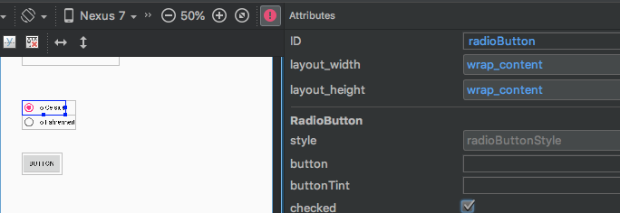

You will now notice in Design view your first radiobutton is automatically checked or set as selected! Notice too that the attribute of “true” has been added to the checked property for your radiobutton.

<**RadioButton  
 ::  
 android:checked="true"** />

Button

Next assign ***@string/calc*** to the text property of your **button** similarly what you did for your radio buttons plus add a tag (new attribute) which assigns the value *onClick* to the *onClick* property. This process eliminates the need for a listener to be added in code, so really you will just create a method called onClick to handle any request by the user later in your Java code.

So for now don’t worry about the warning for a handler needed.

EditText

Set your *InputType* property values to included both *numberSigned* and *numberDecimal* to allow for decimal input entry as well as the ability to enter negative values for temperatures. Use the pipe **|** on your keyboard by using your **Shift + \** key to set two values for the same attribute (sample tweak follows).

<EditText  
 android:id="@+id/editText"  
 ::  
 android:inputType="numberDecimal|numberSigned"

::

Finally adjust the EditText to allow for the element to automatically receive focus at run time. Tweak the tag as follows. Make sure to include a seperate close tag ending to allow for the <requestFocus />. Notice your EditText element has changed from a closed tag ending to just an open tag that just closes.

<EditText  
 android:id="@+id/editText"  
 android:layout_width="wrap_content"  
 android:layout_height="wrap_content"  
 android:layout_marginStart="40dp"  
 android:layout_marginTop="28dp"  
 android:ems="10"  
 android:inputType="numberDecimal|numberSigned"  
 tools:layout_editor_absoluteX="48dp"  
 tools:layout_editor_absoluteY="34dp" >

<requestFocus />

</EditText>

ConstraintLayout

All your user interface components are now contained in a layout. You can assign the background color to this Layout. For your opening ConstraintLayout tag, select the **background** attribute and add in **@color/myColor** to pickup your attribute value you previously defined in your **strings.xml** file. Voila! Your background now has changed immediately to a nice Mistyrose look n feel!

Your opening tag should now reflect the following line added in

<android.support.constraint.ConstraintLayout xmlns:android="http://schemas.android.com/apk/res/android"  
 xmlns:app="http://schemas.android.com/apk/res-auto"  
 ::  
 android:background="@color/myColor">

**Keynote**

Note that sometimes XML element nodes or roots can end simply

with a **/>** at the end of a closing attribute or a standalone ending

with the element name. Ex., **</EditText>**. Either way is acceptable.

Now if you ran your app right now, chances are the constraints for each of your views for each of your elements won’t have an ideal placement for your app. To adjust for the ‘automatic creation of contraints’, merely click the ‘Infer Constraints’ icon in Design view (snapshot follows) to allow for the adjustments to your element placements. You should immediately see constraints added into the design of your app in Design / Blueprint modes.

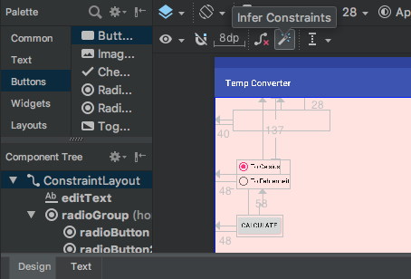

Check over your XML code when you have pressed the icon and see some added contraints added in!

Sample addition of constraints in XML Text view for the RadioGroup element is shown below.

<RadioGroup  
 android:id="@+id/radioGroup"  
 android:layout_width="wrap_content"  
 android:layout_height="wrap_content"  
 android:layout_marginStart="48dp"  
 android:layout_marginTop="137dp"  
 app:layout_constraintStart_toStartOf="parent"  
 app:layout_constraintTop_toTopOf="parent">

**STEP 6 Creating a utility class**

Create the following utility class to enable the conversion of celsius to fahrenheit and vice versa.

To add in a class to your project, go to your project tree view, and right click on your app/java folder, then within your package (same package as your MainActivity.java class file) select

**New > Java Class**.

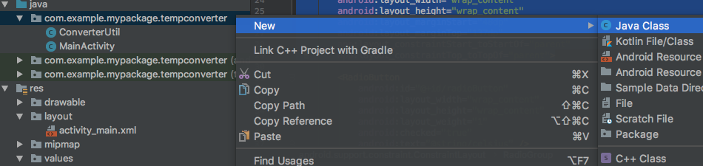

Name your class **ConverterUtil** within the Create New Class dialog box (shown next) and then click Ok to close out the the dialog box appears.

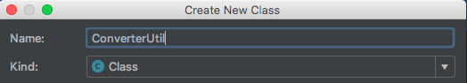

Enter in the following code verbatim as you see below (note your package name may differ for all the code logic for this lab, which is okay!!!).

package com.example.mypackage.tempconverter;  
  
*/**  
 * Created by minimac on 8/26/2018.  
 */*public class ConverterUtil {  
  
 */**  
 \** ***@param*** *fahrenheit  
 \** ***@return*** *\*/* // converts to celsius  
 public static double convertFahrenheitToCelsius(float fahrenheit)  
 {  
 return ((fahrenheit - 32) * 5.0 / 9.0);  
 }  
  
 */**  
 \** ***@param*** *celsius  
 \** ***@return*** *\*/* // converts to fahrenheit  
 public static double convertCelsiusToFahrenheit(float celsius) {  
 return (celsius * (9 / 5.0)) + 32;  
 }  
}

**STEP 7 Updating your MainActivity code**

At startup of your project, Android Studio project wizard created the corresponding **MainActivity** class for your activity code. Adjust this class with the code below. Note, put in all the needed import statements below and code logic in your file. You’ll notice that some code wraps to a new line due to the constraint set by margins.

package com.example.mypackage.tempconverter;  
  
import android.os.Bundle;  
import android.support.v7.app.AppCompatActivity;  
import android.view.View;  
import android.widget.EditText;  
import android.widget.RadioButton;  
import android.widget.Toast;  
  
public class MainActivity extends AppCompatActivity {  
  
 private EditText text;  
  
 @Override  
 protected void onCreate(Bundle savedInstanceState) {  
 super.onCreate(savedInstanceState);  
 setContentView(R.layout.*activity_main*);  
 text = findViewById(R.id.*editText*);  
 }  
  
 /* this method is called when user clicks the button and is handled  
 because we assigned the name to the "OnClick property" of the  
 button */  
 public void onClick(View view) {  
 switch (view.getId()) {  
 case R.id.*button*:  
 RadioButton celsiusButton = findViewById(R.id.*radioButton*);  
 RadioButton fahrenheitButton = findViewById(R.id.*radioButton2*);  
 if (text.getText().length() == 0) {  
 Toast.*makeText*(this, "Please enter a valid number",  
 Toast.*LENGTH_LONG*).show();  
 return;  
 }  
 float inputValue = Float.*parseFloat*(text.getText().toString());  
 if (celsiusButton.isChecked()) {  
 text.setText(String.*valueOf*(ConverterUtil.*convertCelsiusToFahrenheit*(inputValue)));  
 celsiusButton.setChecked(false);  
 fahrenheitButton.setChecked(true);  
 } else {  
 text.setText(String.*valueOf*(ConverterUtil.*convertFahrenheitToCelsius*(inputValue)));  
 fahrenheitButton.setChecked(false);  
 celsiusButton.setChecked(true);  
 }  
 break;  
 }  
 }  
}

Note that whenever in the future you add in some code logic such as assignment statements especially involving some object creation or reference, etc., you probably will need some import statement(s) otherwise the system will flag you if not. A quick fix is to go to the end of your line that is flagged and press **Alt+Enter**. Note you can also automatically fix import errors or “clean up” any unnecessary imports by choosing from your menu **Code > Optimize Imports.** Be forewarned though when using such an option though as sometimes imports can be seen as not to be inclusive as a suggestion and yet you may deem that a particular import(s) is perhaps necessary to keep.

Sample snapshot shows a pop up error message for a given widget that has no import statement.

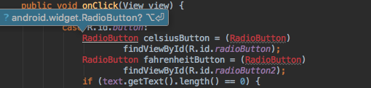

If you’re used to shortcuts, please visit this [link](https://developer.android.com/studio/intro/keyboard-shortcuts) which show shortcuts operable in Studio.

**STEP 8 Running your application**

Whew! Time to run this pup. Assuming you have set up a Virtual Device in Studio, press **Run > Run ‘app’** from your menu or merely right click on your project MainActivity file and choose Run ‘MainActivity’. At the Select Deployment Target pop up, use your default device created in the hello world example specs (which should be selected), check the option ‘Use same selection for future launches’, and press OK to run your app (snapshot follows). You should now see your AVD Emulator loading and your app finally running!

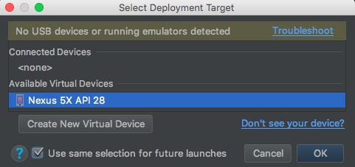

Press OK to accept your choose to let your emulator run.

Test your running app

Click once inside your text field (cursor should be showing as a prompt) and type in a temperature value, select your conversion and press the **Calculate** button. The result should be displayed back onto the text field and the other option button should get selected designating the resultant converted degree type. Try also pressing Calculate without any value in the text field, you should get a warning Toast pop up message!

Sample emulator at runtime snapshot.



**STEP 9 Modifying your Android application**

Okay you have come this far! Congratulations! Time now to modify what you’ve

done to include some extra nice features for your app. Modifications will include adding an changing the background color of your app depending on the temperature. Perform the following tweaks.

In your layout view file, activity_main, give an id to your constraint layout’s opening tag, called activity_main, as follows:

<android.support.constraint.ConstraintLayout xmlns:android="http://schemas.android.com/apk/res/android"  
::  
 android:id="@+id/activity_main">

Save your file. Now you will be able to change colors of your layout background by referring to the id of the layout.

To change the background colors for various temperatures either being too hot or too cold in code, open up your MainActivity file and add in the following code enhancements.

Right towards the beginning of your class declaration, after the opening tag add in the following line of code to create a view object

**View view; //create object to manipulate background color**

If you like, this could be place directly after your declaration of your text object namely,

**private EditText text;**

Next in your **onClick** method, add in the following code logic *after* the last if/else statements but *before* the **break**; line, as follows

//grab CURRENT result value now in Text Field  
inputValue = Float.*parseFloat*(text.getText().toString());  
view = findViewById(R.id.*activity_main*);  
if (inputValue>90){  
//set hex color to skyblue  
 view.setBackgroundColor(Color.*parseColor*("#87ceff"));  
}  
else view.setBackgroundColor(Color.*YELLOW*);

You’ll notice in the code above, that a view object was created to point to the id of app’s ConstraintLayout element, namely **activity_main** to allow the altering of the app's background programmatically. Note the **setBackgroundColor** method which takes in a color of our choice. You can either choose the intellisense offerings for some standard colors (Yellow) in our case or include some hex values (#87ceff),aka *skyblue*, as our alternative choice.

For more hex color choices visit- <http://cloford.com/resources/colours/500col.htm> .

Notice in the if conditional logic it states to choose a background color of Skyblue if the temp result in the Text field yields a temp greater than 90 otherwise it defaults to Yellow.

Finally make sure to have the following import statement amongst your list of imports.

**import android.graphics.Color;**

Modify your code such that the background color turns red if the temp drops below zero (like our Chicago temps at times).

Run and test code to see if things work out with various temperatures. App lookin’ pretty cool now huh?

Grad credit.

Adding in images to your app. This last part will be similar step 9 above and other prior steps work. Here you will add in two images to your app and then display them based on certain temp results.

Grab 2 picture files of reasonable size from the web. One picture can represent warmth like a sun picture and the other to represent coldness like a frosty picture, etc. Copy and paste your images one at a time into res/drawables folder. When prompted for a destination directory you can just choose the first option as shown below.

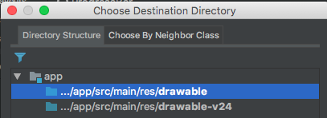

Next pop up just make sure the name of the file and chosen directory to save the file looks correct. Example follows.

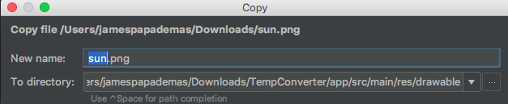

Now add in an ImageView from your Palette Widgets container choices, after your button in design view. You should now be prompted with a screen to add in Resources such as an image to include for your object. Type in transparent at the search area on top and choose under the android pull down choice, the screen_background_light_transparent option and click OK as shown next.

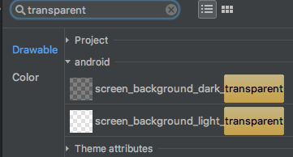

Now open your MainActivity file, and in your code, declare right after your class starts, another object, this time an ImageView object as follows.

**ImageView iv; //create iv object to manipulate image view**

Next after your second if statement, add in the assigment statement for iv object shown in red below.

//grab result value now in Text Field

inputValue = Float.*parseFloat*(text.getText().toString());

view = findViewById(R.id.activity_*main*);

iv= findViewById(R.id.*imageView*);

Lastly “adjust” your last conditional logic block by adding in the red highlighted code shown below which renders a “sunny” image if temperature exceeds 90 degrees.

**if** (inputValue>90) {

//set hex color to skyblue

view.setBackgroundColor(Color.*parseColor*("#87CEFF"));

iv.setVisibility(View.*VISIBLE*);

//clear any prior image

((ImageView) iv.findViewById(R.id.*imageView*)).setImageResource(0);

iv.setImageResource(R.drawable.*sun*); //show sun on image

}

**else**

{

view.setBackgroundColor(Color.*YELLOW*);

iv.setVisibility(View.*INVISIBLE*);

((ImageView) iv.findViewById(R.id.*imageView*)).setImageResource(0);

}

Notice the added code will either set the visibility of the image to VISIBLE or INVISIBLE depending if you want the image to show at various temperatures. Also your image source can be set programmatically by the setImageResource method to point to any existing image in your drawable folder you specify (sun in this case) and you can also set the clearing up of any resources used by the ImageView (any existing image in memory) by passing a **0** in the setImageResource parameter via the iv object.

Finally make sure to add in the following import statement.

**import** android.widget.ImageView;

Run your app and test it now thoroughly for temps above and below 90. If your image does not display, check your layout configuration settings and/or the size of your image if some settings are causing rendering issues. *You can always adjust your Attribute settings for your component to tweak settings such as height/width setting them to a desired dp, as well as checking any other settings such as* the *scaletype property to adjust positioning (ex. To center) or as another example the layout_alignParentLeft setting). Check any intellisense choices for more desired settings…*

For more on dpi’s and unit measurements visit this [site](https://www.google.com/design/spec/layout/units-measurements.html).

Modify your code to include an image of your choice when the temperature drops below zero. Note if there are any images between 0 and 90 showing as a result, something in your logic needs tweaking! Test it out.

Extra credit (all).

Adding in a **Home Screen** desktop icon for your app.

Grab a suitable icon (**.png** or**.jpg** file formats and small to medium file sizes will do just fine) from your favorite search engine. Download an icon that relates perhaps to weather or temperatures and where you will copy in the icon into your **res/mipmap** folder under the root of your project. Name your file to whatever you like. Note to copy files into your folder you can right click on your folder and choose paste. When prompted for a Destination directory, choose the following.

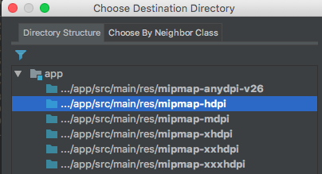

Click OK to continue.

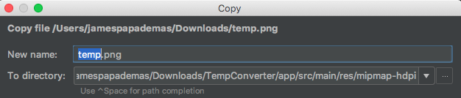

Click OK to finish.

Next go to your **manifests/AndroidManifest.xml** file and go to the line under the application root and set the **android:icon** property value to include just your file name you have for your icon.

Ex. I have a file icon called **temp** with an extension of .png.

I would include the following tweak to the **AndroidManifest** file...

<application

android:allowBackup=*"true"*

android:icon=*"****@drawable/temp****"*

::

Basically you are now telling Android to start up *not* with the default desktop Android icon  but your own!

Next right click on your mipmap folder and choose New > Image Asset and where it says Path: point to your current mimap image file. Click Next, then Finish.

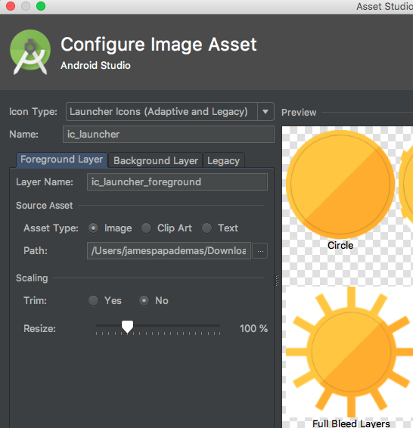

You can try and run your app to see if this kicks in for you. Check your actual desktop on your phone to see the resulting new icon. To view your desktop apps/icons, just swipe upwards towards the bottom of your visible emulator screen.

**STEP 10 Submitting Your Program Code and Your Run Time Output**

For full credit make sure to include any source code and snapshots for a completed submission. Also make sure your code is complete with comment statements where necessary and include a brief program description at the top area of your MainActivity java file.



**For full credit!**

**Take the following snapshots of your app in action. LABEL your snapshots**

**accordingly.**

1. Take a snapshot of your running application, which will show the result of 40

degrees Celsius converted to Fahrenheit.

1. Take snaps showing each background color that triggers for a very warm temp and a very

cold temp. Include snapshots for red, skyblue and yellow colors.

1. Grads. Make sure to show images for temps greater than 90 or below 0 and a temperature in between like 30 degrees Fahrenheit.
2. Extra Credit. Show snapshot of your Home screen showing your custom icon display.

To easily create snapshots follow these basic suggestions if you will.

1. For Mac/Windows, just press the the camera icon on the extended controls of your emulator

to have a snapshot saved to your Desktop. Preview your snapshot and get it copied into a Microsoft Word Document.

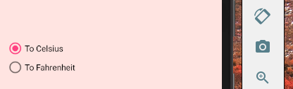

2. Use the Windows Snipping Tool built in the Accessories group in Windows 7,8 & 10 or Mac

people can use Skitch, which is a free download.

**Copy and paste the following files into MS Word. Your java files and any XML files**

**(including your AndroidManifest, strings, activity_main).**

Include your **name**, **lab number**, **course number/section** and the **date** at the top of your

Word doc. Please do this for all labs. Name your Word doc file to include your first initial

Underscore, followed by the first 4 letters of your last name followed by another underscore and

the lab number (ex. S**_polk_lab1**).

Proper documentation including comments in your java source files and any error traps will

always be throughly checked as being part of your grade so make sure to include these items

where applicable!



**General App Troubleshooting Tips**

1. Clean your project to clear errors by going to Build > Clean Project

then if necessary run your application to see if everything also clears!

2. Do a **Save All** perhaps to update changes in your file(s).

3. Shutdown/restart Studio – if don’t see an error go away after a clean!

4. Shutdown your running AVD and restart app from scratch.

5. Reset your AVD or create a new one (to handle differing Api’s)

Experiment with different RAM settings, VM bytes for added acceleration/performance.

6. Check any code that maybe in question along the way, especailly when your Build

your project (do Build > APKs as a check for errors). With a lot of code and dark

backgrounds fonts in your editor it may be hard sometimes to detect. Check for valid

import statements!!!

Use the Messages view in Studio if it’s not visible, View > Tool Windows > Event Log, to help pinpoint gradle builds.

7. Check your XML properties & attributes!

8. Check log files/Gradle Console/Problem Windows, etc.

9. Desktop maintenance – deleting old/similar apps by project name.

10. Use various Studio window views when your app starts up or is running to detect your

background processes, app build intel, logs (via Logcat view) etc.

Always have these open at runtime to monitor / debug things!

What are your tips/errors? Please **share** in the Discussion forum in Blackboard!